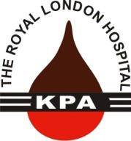

**KPA NEWSLETTER. SPRING 2018**



RLHKPA Registered Charity 266660

[www.rlhkpa.org.uk](http://www.rlhkpa.org.uk) fb rlhkpa

Editorial

Welcome to the Spring 2018 edition of the RLHKPA Newsletter. Hopefully we have included some articles that you will find interesting and/or helpful.

Sadly, the KPA /Patients Forum have lost a giant within our community with the sad passing of Ronnie Moodley MBE. His funeral was held at the City of London Cemetery and Crematorium and was a celebration of his life. This was very well attended by both Bart’s staff and patients along with friends and family of Ronnie. Brian Gracey, Chair of the Renal Patients Forum has written a Tribute to Ronnie which appears later in this newsletter.

There is an article regarding Home Haemodialysis written by Richard Endacott which hopefully you will find interesting and even thought provoking to a different way of dialysing to some of you.

As this is before the summer holiday period there is an article listing Insurance companies, reproduced from a NKF article, who provide insurance for pre-existing medical conditions. As always with this type of article, please be aware that you need to ensure the insurer is informed of your medical conditions.

We hope you enjoy this edition and if you have ideas you feel should be included in future editions, please let us at the KPA know.

Les Petchey

Inside This Issue

1. Editorial

3. Dates for your Diary

4. Ronnie Moodley Tribute.

6. East London Community Kidney Service.

1. Home Haemodialysis – Is it an option for you

16. Holiday Pull – Out.

21. Holiday Insurance and Advice.

27. British Transplant Games

29. Dr M Raftery’s Retirement

31 World Kidney Day



|  |  |
| --- | --- |
| Pesach (Passover) | 30th March – 7th April Jewish |
| NKF KPA Day (Incl AGM) | 7th April at The Glebe Hotel, Church St, Barford, Warwick CV35 8BS |
| Good Friday | 30th March Christian |
| Easter Sunday | 1st April Christian |
| Vaisakhi | 14th April Sikh |
| Quiz Night | 21st April 7pm Dagenham & Redbridge FC |
| **Committee Meeting (3)** | 16th May |
| Ramadan (Fasting & Prayer) | 15th May – 14th June Muslim |
| Country Fair Eastbrookend | 24th June. |
| Vesak (Buddhas birthday) | 29th May Buddhist |
| Pentecost (Whitsun) | 30th May Christian |
| Eid al-Fitr (Last day of Ramadan) | 14th – 15th June Muslim |
| **Committee Meeting (4)** | 4th July |
| British Transplant Games | 2nd – 5th August Birmingham |
| **C**ommittee Meeting (5)** | 12th September |
| Memorial Service | TBA Great Hall Barts Hospital |
| Quiz Night | 27th October 7pm Dagenham & Redbridge FC |
| **AGM (6)** | 7th November |

**Ronnie Moodley 24th September 1950 -9th February 2018.**

We were all saddened to learn of the death of Ronnie Moodley, on Friday 9th February. He had his family, friends and colleagues with him when he passed away.

Those of us who were fortunate enough to have known Ronnie recognised in him an indomitable spirit and a perseverance to get things done. As a member of the Renal Patient Forum since its inception in 2012/2013, we came to rely on someone who fought hard for the patients and who was determined to ensure that the experience of renal patients was improved across the Trust. Before I say more about what Ronnie achieved as a member of the Forum, it is a fascinating story to understand a little about how he came to be in the UK. It is the stuff of Hollywood movies and perhaps one of these days a film will be made of his life……

Ronnie was born in South Africa on the 24th September 1950. At the time South Africa was operating a strict system of apartheid and Ronnie’s family were deeply affected by the discrimination endemic in South Africa at that time. His parents were killed in a car bomb when Ronnie was only five years old and, as an orphan, Ronnie was taken into the care of a Convent. By all accounts he had a very unhappy time there and was not well looked after. As an adult he involved himself in the African National Congress (ANC), the anti-apartheid movement and was imprisoned for his activities. He was imprisoned on Robben Island, where Nelson Mandela was incarcerated for so many years.

During his time there he was visited by a friend who brought with him a nun costume and, disguised as a Nun, Ronnie managed somehow to escape from Robben Island and was eventually able to make his way to an airport where he boarded a fight to Europe.

He had been intending to fly to Holland but decided to disembark in London and, as an asylum seeker, was granted asylum by the UK authorities, With no more than £5 in his pocket, he bought a tube ticket to central London arriving there in 1987 with not a penny to his name.

Ronnie made his way to the East End and, over the next few years, assisted with the establishment of a number of organisations to help those who were in a similar situation to himself. At the celebration of Ronnie’s life, on Tuesday 6th March 2018 at the City of London Crematorium, a number of Ronnie’s friends paid moving tributes to how Ronnie had helped them over the years.

In 1992, Ronnie married and his wife gave birth to a Son, Andrew, the following year. Ronnie suffered ill health throughout his life and had been diabetic for many years. His sight had deteriorated and his kidneys finally failed, leading to the need for Ronnie to have to dialyse.

In 2003, Ronnie was awarded the MBE for his services to refugees. In 2012, Ronnie’s ill health took a further cruel turn when he was told he would have to lose part of his left leg. Throughout all this time, however, Ronnie never gave up, he never believed he should stop helping other people and he always maintained his sense of humour.

As a founder member of the Patient Forum, Ronnie was involved in all our issues. He was particularly determined to ensure the transport providers maintained a quality service for dialysis patients. We were not always successful in this aim but we never stopped trying. Ronnie also chaired the Well Run Ward sub group and brought his inimitable style to his desire to ensure that standards were maintained and improved in the dialysis units.

It was a great shock to all of us that Ronnie passed away so quickly. We feel privileged to have known Ronnie and shall miss him enormously.

Our thoughts are with his Wife and Son at this particularly difficult time.

**Brian Gracey, Chair Renal Patients Forum.**

**East London Community Kidney Service.**

An East London community kidney service has slashed hospital waiting times for people with chronic kidney disease. An innovative virtual e-clinic at The Royal London Hospital is enabling the hospital’s kidney experts to view GP patient records and provide instant advice to GPs about the next steps for patients care.

This has reduced the number of patients that need to see a specialist face-to-face by 31% and saved the NHS over £30,000. Patients who do need hospital care now await just one week for specialist assessment compared to previous waits of almost three months.

As well as being able to provide specialist advice and easily share test results, automatic triggers alert GP practices to patients at risk following routine blood tests and GPs can monitor their patients wellbeing electronically.

The service model, run by Barts Health NHS Trust and Queen Mary University of London, has been chosen by the Health Foundation as one of 21 health care projects to benefit from its £1.5 million innovation programme ’Innovating for Improvement’.

The team will now use the funding to translate their research into helping clinicians make the best possible decisions for patients, and develop a support package for GPs to use.

The long term goal is to reduce progression to end stage renal disease. The aim is to improve management across the CKD pathway. From the Tower Hamlets CCG pilot, the project has spread to 1.2M East London adults in NHS City and Hackney, NHS Newham, and NHS Waltham Forest. It is envisaged that a similar programme will soon include NHS Barking, Havering and Redbridge.

**Neil Ashman, consultant renal physician, said:**

“Twenty years ago a GP would have phoned up a consultant and asked for advice. The e-clinic restores this immediacy and its beginning to revolutionise our service. When reviewing patients, we have access to all the investigations done in the community, enabling us to provide comprehensive management advice whilst avoiding unnecessary duplication of tests.

If people do need to be seen at the hospital, we have more availability in clinics to see them in a timely fashion. This funding will now enable us to build on this model and further evaluate our approach.”

**Sally Hull, Clinical Lead for the Clinical Effectiveness Group, Queen Mary University of London said:**

“This project provides a fantastic opportunity to test out ways of improving the primary care identification and management of chronic kidney disease.

Evaluating the whole community kidney service system, including specialist services, GP management and focused practice facilitation, will provide evidence on the effectiveness of this approach, and its impact on patient care.”

Innovative materials, developed with patients including the ‘conversation map.’ ”Diabetes Conversation Maps” are effective for diabetes self-management education and facilitate behaviour change in people with type 2 diabetes.” (Ghafoor 2015)

(See the “conversation map” at the end of this article.

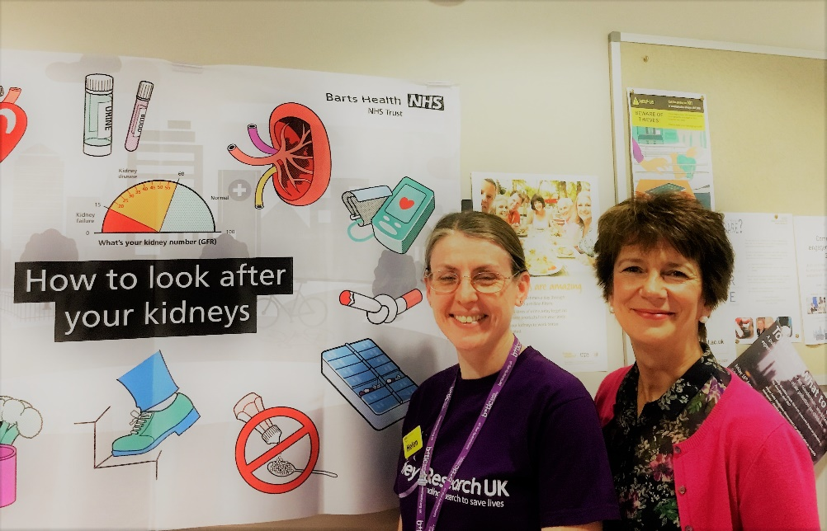The project was set up by Dr Neil Ashman - Kidney Physician,

Sec Hoong – Project Manager, Sally Hull – GP and CEG Lead,

Helen Rainey – Clinical nurse specialist for Kidney Disease and

Prof Nicola Thomas – Kidney Nurse and Professor of Kidney Care.

(Pictured) Helen Rainey (left) and Prof Nicola Thomas (right).

Helen and Nicola have been running the patient education aspects of the service and have developed new patient resources that try to explain how people (particularly those with diabetes or high blood pressure) can help slow down their kidney failure by changing their lifestyle. The next planned stage of the project is to see if it is making any difference to their knowledge about kidney disease and the factors that may slow down the rate at which their kidneys fail. Another part of

this stage is to find out if nurses working in GP surgeries use the education materials during their appointments with patients and whether they have any feedback for the team. This part of the project is being funded by the RLHKPA.



“Conversation Map”

For her work with the Community Kidney Service, Helen Rainey was awarded ‘Renal Nurse of the Year’ in the recent British Journal of Nursing Awards.

We all wish our congratulations to Helen and shows how our staff are involved in work that benefits the greater kidney community.

Once again, ‘Well Done Helen, well deserved.’

**HOME HAEMODIALYSIS - Is it an option for you?**

**BACKGROUND**

Across renal units in the UK home haemodialysis (HHD) currently varies between 0-11% of all haemodialysis patients (HD), and less than 10 hospital units have more than 5% of their patients on HHD. Despite the evidence for its clinical superiority, patient acceptance and cost effectiveness home Haemodialysis has an extremely low UK average prevalence of 1-2%. The number appears to have been in decline since its height in 1983, when 59% of patients dialysed at home. It then seemed to plateau in 2003 and has been declining ever since. There are many complex reasons for this fall off and space does not permit me to give all the reasons here. The diagram below illustrates the types of dialysis in the UK, for new renal dialysis patients in the first 90 days and a percentage breakdown of each. (1)

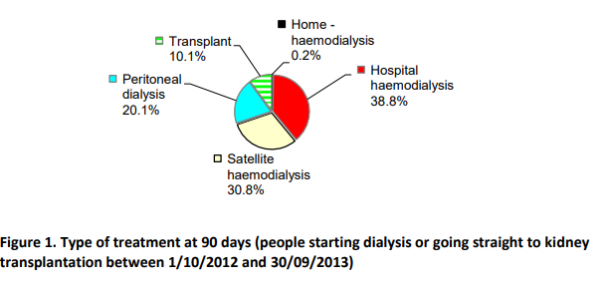

The percentage figures shown above don't alter that much from the dialysis population of the UK as a whole. Around 64,000 patients are on a form of renal replacement therapy (RRT) i.e. dialysis, and 1200 of those are on Home HD. There are 5500 people waiting for an organ transplant and every day five people are added to the list, with an average wait of 3 years. Choosing the right dialysis that suits you and your way of life is therefore a hugely important decision for the patient.

Ever since the 1950s, when RRT had its origins, we have been looking to improve the dialysis experience and quality of life for patients. There are now several types of dialysis for the new patient, and the place of treatment is often decided following discussion with the renal team. It is always the aim to try and fit the type of dialysis (often called modality) to each individual's needs and circumstances. The choice is one of CAPD (Continual Ambulatory Peritoneal Dialysis) or APD (Automated Peritoneal Dialysis. The latter is normally overnight, leaving the daytime free. PD is frequently the first choice for patients, if they are suitable, due to its ease of use and relative simplicity. The other main option is haemodialysis (HD), and the machines are familiar sights in renal units. These clever machines filter and clean the blood, also removing any excess fluid, normally over a four to five hour period. This process needs to happen at least three to four times a week. HD is carried out mainly in hospital, at satellite units and at home. It is not uncommon for a new patient to start on CAPD at home, after a few years switch to HD at a central unit and then at some point move back home as a haemodialysis patient.

**OUR RENAL UNIT**

In our Trust we have around 1350 patients on dialysis with 64%, 29% and 7% on HD, CAPD and transplanted respectively. This relates to patients within the first 90 days of starting treatment. We currently have approximately 30 home haemodialysis patients with several more patients undergoing training now. This is a small number, but there are many understandable reasons why the take up remains low. Amongst these are unsuited housing and lack of space at home. A study by Dr Suzanne Forbes et al found that in East London 0.5% of residences met requirements for home Haemodialysis. There may also be a natural fear of not appearing to have immediate medical and technical back up should the machine or dialysis session have problems. Furthermore, patients may find training difficult and complicated and may lack confidence with the learning of new procedures. And then there's the subject of needles! That is, inserting them yourself or helped by your partner.

**SO WHAT'S TO GAIN FROM HOME HAEMODIALYSIS?**

1 You can dialyse at a time that is convenient to you, and which best fits your commitments to work, family, hobbies etc.

2 It means no travelling back and forth to the unit, which can add another few hours to your session.

3 As this is your own machine you are able to dialyse more frequently or for shorter or longer periods as required. Home HD patients normally dialyse every other day sometimes more often, which over time has been shown to improve measured clinical outcomes (ie through clinical studies).

So for those up for it and who have had the recommendation and approval from your consultant the rewards could be there for the taking. Of course it is really important that patients are willing to undergo the training as this is a little more involved than PD. At our unit comprehensive training and familiarisation is provided and we are lucky to have a new four station unit on the 9th floor which just opened at the end of last year. This fabulous set up can allow patients to be home within a number of weeks. All patients can gain confidence at their own speed and the training caters for this.

**MY SET-UP**

I have been dialysing at home now for three and a half years and the switch from centre based haemodialysis to home has completely changed my quality of life, making a huge difference to both the flexibility of my family life and the independence to manage my own time. Not having spare bedroom space, I was lucky to be able to convert my old office in the garden to a dialysis room. I enclose a couple of pictures of my set up. Other very suitable locations are a spare or main bedroom.

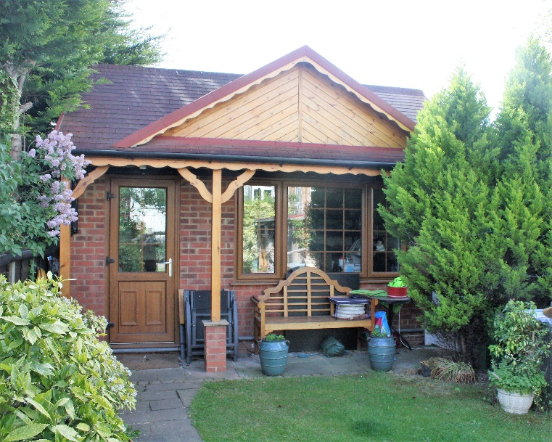Some level of organisation is required if you want things to run smoothly! You need space near to your machine for your dialysis materials - your lines, needles fluids and other disposables. I use a six shelf flat-pack metal shelving unit which I bought on line for about £15. Stock not for immediate use I stack on a similar unit in my garage. It is also recommended to maintain adequate stock levels

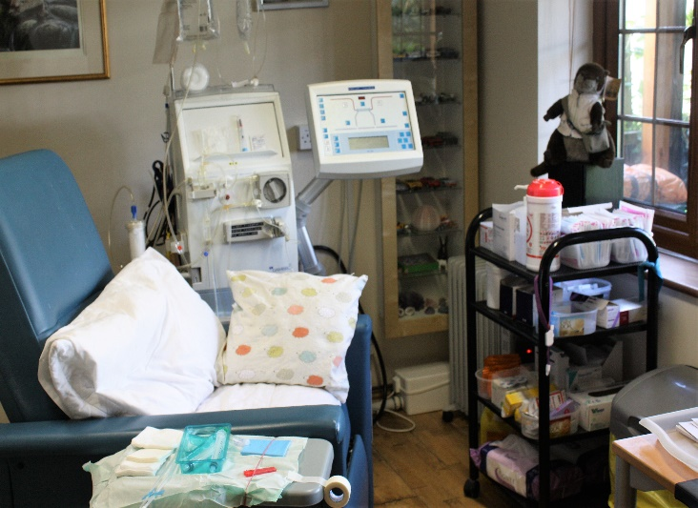especially dialysates which are bulky and heavy. It would be tricky carrying that back on public transport from your unit if you run short. Baxter will contact you for your order and deliver your supplies once a month. They will carry all supplies to where you need them in your home.

If there are any issues with the machine, which always alarms if there is a problem, there is a very proficient technical support team at the end of the phone. They are available during the working week and then on call at any time out of hours. That is 24 hours a day, seven days a week. Trouble shooting and sorting out machine stoppages yourself increases with experience, as you start to recognise the possible problem. Of course there are some things that you can't control, and with the recent visit from the "Beast from the East" my pipe work froze and along with three other patients on HHD I had to run to the unit for our sessions until it all thawed! I have had very few machine issues that could not be rectified by a technician's expert advice on the phone. Only twice in 4 years have technicians had to come to me to make a repair. The technical support team comes every three months to service the machine, replace filters and the like and re-test the whole system.

**HHD FOCUS GROUP**

From a Trust and Department perspective the encouragement of patients to take a role in either shared or self-care is a high priority and is promoted to all dialysis patients, especially new patients and those attending low clearance clinic. With this in mind we have started a HHD focus group (approx. 8-10 people) which meets every 2 months. We had our first meeting last summer, and are a mix of HHD patients, nurses and clinicians, including relevant senior renal team staff. One of our key aims is to discuss ways to promote best practice and develop and generate a culture where patients feel encouraged to adopt some of the tasks required in running their dialysis session. I am pleased to add that I have had invaluable support from senior management in pushing forward with this mission.

As a focus group one of our key activities this year is the continuing series of HHD Roadshows at our satellite units. These events are run over two days and I along with other group members meet with patients to discuss the benefits of shared and self-care. Vitally we talk with patients about their experiences, likes, dislikes and sometimes fears, and look for ways to help each other and build more confidence. We ran the first Roadshow late last year at Queens, where Franel and his team manage a highly organised unit where self and shared care is top of his agenda. It was an excellent 2 days and generated many useful conversations!

Finally, I feel personally that having a strong desire to be independent, be at home, plus having a positive attitude to new challenges and training will go a long way to becoming a HHD patient. I have met many home HHD in my travels and not one of them regrets the decision to move to HHD. I wish you luck and contentment on your dialysis journey.

Richard Endacott

Chair Home Dialysis Sub Group

Renal Patients Forum.

**References**

UK Renal Registry 2016

NICE Setting up Home Dialysis Programme. Shared Learning Database Central Manchester Foundation Trust 2012

Forbes et al 2013 BMJ "Is Lack of Suitable Housing a barrier to home based Dialysis."

.

### RLHKPA Holidays

**Poole Flat**

There are holidays for all members: Pre-dialysis, CAPD, Home and Unit based Haemodialysis and Transplant patients and non-patient members.



**How to book a holiday**

1. Check with your Unit that you are well enough to go on holiday.
2. Choose the date(s) you wish to go – giving second and third choices.
3. You may also request a second holiday, perhaps to follow on giving you two consecutive weeks, if bookings allow. Second holidays are allocated from March.
4. Complete the Booking Request Form, sign the declaration then send to Margaret Craddock (address on form). Send no money at this stage.

**Please book early to avoid disappointment!**

Confirmation of your holiday will be sent to you together with payment slips, details of the home and a map of how to get there.

**APD/CAPD patients**

Your dialysis supplies can be delivered direct to your holiday home provided

you give the Home Dialysis Manager at least three weeks’ notice.

**Haemodialysis patients – Unit/Satellite based and Home patients**

Arrangements may be made for haemodialysis patients staying at the Poole flat to dialyse at the KC Holiday Dialysis Centre at Bournemouth. The arrangement of dialysis treatment is subject to availability at the time of booking. The RLHKPA pays, where necessary, for transport to and from the dialysis centre.

**Important:**

Unit/Satellite based patients must ask their Unit’s advice before booking.

Haemodialysis patients must be stable **on treatment for six months**

prior to their holiday.

|  |  |  |
| --- | --- | --- |
| **HOLIDAY HOME** | **CONTRIBUTION\***  Inclusive for up to six persons | **DATES FOR 2017**  **(**w/b = week beginning) |
| Poole Flat | £200 per week  £75 (except during  £125 school hols.) | w/b Sundays  weekend (12 noon Fri – 12 noon Sun) Mon-Fri (12 noon Mon – 12 noon Fri) |

* Requests for financial assistance towards contributions are considered on an individual basis. The KPA is unable to fund alternative holidays.

**Accommodation for up to 6 persons**

|  |  |  |
| --- | --- | --- |
| Bedroom 1  two single beds | Bedroom 1 (partitioned)  Two child bunk beds | Bedroom 2  one double bed |

The Association runs a self-catering holiday flat at Poole (Bournemouth) in Dorset. Administration and maintenance are carried out voluntarily and no profit is made. The home is available to ALL members.

The flat is on the ground floor of a block of six residential flats and, being centrally heated, is available for holidays throughout the year. Bournemouth town centre is a short bus ride from the bus stop outside the flat and, for those more energetic, a gate at the rear of the property opens onto the Central Gardens and affords a pleasant walk to the main beach, pier and shops. The flat is ideally situated for enjoying the south coast with its picturesque villages and the New Forest. (Haemodialysis treatment may be arranged, subject to availability at time of booking.)

The home is well appointed and provides:

* + accommodation for up to six persons;
  + lounge with colour television/integral DVD;
  + well-equipped kitchen with fridge, electric cooker, microwave and a washing machine;
  + central-heating / hot water;
  + shower;
  + facilities for safe CAPD exchanges and APD; and
  + garage parking .

**NB It is advised that Members on Haemodialysis book early.**

**BOOKING REQUEST FORM – POOLE FLAT**

**Name Please Tick:**

Pre-dialysis◻ Haemodialysis ◻ CAPD ◻ Transplant ◻ Other ◻



**Address**

**Post Code Tel. No**.

**Holiday request** – Week beginning Sunday:

1st choice 2nd choice 3rd choice Sunday

For Weekend or Midweek break, phone 01277 810326

**Please arrange Haemodialysis treatment for me at the KC Holiday Dialysis Centre**. (Please tick if required: ◻ )

Date of birth Dialysis unit Usual dialysis days

**Please list the names of ALL your holiday party**

|  |  |  |  |  |
| --- | --- | --- | --- | --- |
|  | Title  (e.g. Mr) | First Name | Last Name | Age  (if under 18) |
| 1. |  | (patient/member) |  |  |
| 2. |  |  |  |  |
| 3. |  |  |  |  |
| 4. |  |  |  |  |
| 5. |  |  |  |  |
| 6. |  |  |  |  |

Send to**: Margaret Craddock, 90 Station Road, West Horndon, BRENTWOOD CM13 3LZ**

**RLHKPA Poole Holiday Home ~ Terms and Conditions**

**PLEASE NOTE: THE FLAT IS A NO SMOKING PROPERTY.**

1. Bookings are only taken from members of the RLHKPA.
2. A member must be **in residence** throughout the holiday period.
3. A **non-returnable** deposit must be paid **on receipt of booking confirmation** and the **balance** paid a minimum of **four weeks** before the holiday.
4. In the event of a cancellation, please inform the RLHKPA promptly so the holiday facility may be offered to other members.
5. Guests must adhere to the stated times of arrival and departure.
6. No pets (except guide dogs) are allowed at the Poole flat.
7. Cars must be parked in the garage (No 4) and not left on the drive.
8. Please leave the garage **UNLOCKED** at all times as Dialysis supplies are delivered directly into the garage throughout the year.
9. Report any problems or breakages so they may be quickly rectified.
10. **Remove** spare dialysis supplies and all food from cupboards and fridge before you leave.
11. Domestic waste must be put in black sacks and placed in the wheelie bin/recycle bins in the front garden. CAPD clinical waste should be put in yellow sacks (provided) and put in the garage.
12. Cleaners are not employed so please leave the flat in a **clean state**

for the next guest.

1. For security and safety **Please note the Check List** on the notice board before you leave.
2. Turn off electric sockets (except kitchen appliances) and lights, lock windows and doors, turn down central heating.
3. Please return the key immediately you return home.
4. The RLHKPA reserves the right to refuse future bookings from guests who contravene these terms and conditions.
5. **Smoking within the property is NOT PERMITTED**.

**Declaration:** I agree to abide by the booking Terms and Conditions

Signed: Date: / /

# MEMBERSHIP ADDRESS LIST

It is our continued policy to keep our mailing list up to date and avoid any undue distress to relatives who may recently have suffered bereavement.

Please help us by advising any deletions, or other changes, by using the form below. Should you wish to receive KPA News by email, please complete the **form** and send your email address to the Membership Secretary.



? ?

PLEASE TELL US

**□ I wish to join the KPA (FREE)**

**□ I am moving home**

**□ I have c h a n g e d my name**

**□ I have c h a n g e d my ’phone’ no.**

**□ I no longer want the Newsletter □ I have changed my email address**

|  |  |
| --- | --- |
| Previous  Name: Address:  Post Code: _ Telephone: Email: | New  Name: Address:  Post Code: _ Telephone: Email: |
| Please send completed form to the Membership Secretary:  42 Ingrebourne Road, Rainham Essex RM13 9AL | |

**Holiday Insurance and Advice**

Most standard Holiday insurance policies do not provide cover for a ‘pre-existing condition’ and the NKF site lists companies that may be able to help.

**Note:** Insurance companies can and do change their Terms and Conditions – always ensure you have current information on polices. Also note that insurance companies usually take each case on its merits; it is usually a case of phoning round *and finding the one that is the most suitable for you.*

*Remember that in Europe, in addition to the correct holiday insurance, you should also carry a European Health Insurance Card (EHIC).*

**WARNING** - Many Insurance Companies take on new policies without asking medical questions. They are able to do this because they rely on a clause in the small print which says that they will not cover pre-existing medical conditions. Patients must realise that such policies do not give them insurance cover and that any claims as a result (both directly and indirectly) of existing kidney disease under such a policy would not be honoured in the event of a claim. Whether you were accepted (without disclosing existing illness) and are paying the premium, is irrelevant in such cases.

To travel abroad without insurance that covers you for your pre-existing medical conditions could be catastrophic financially.

The RLHKPA cannot accept responsibility for information provided. The above, and the following listing of companies is for guidance only.

If you are happy with any of these, or any other company, please share the information with us so others can benefit.

|  |  |  |
| --- | --- | --- |
| COMPANY | CONTACT DETAILS | COMMENTS |
| Able2Travel | 0845 839 9345 | Specialise in travellers with medical conditions. |
| All Clear Ins Svcs | 0870 777 9339 | Worldwide |
| ASDA Insurance | 0845 300 7131 |  |
| Avanti Travel Ins | 0800 066 5604  www.avanti.co.uk |  |
| Direct Travel Insurance | 01903 812345 | Europe/America/Canada |
| Free Spirit | 0845 230 5000 | Europe |
| Freedom Ins Svcs | 01223 454 290 | UK, Europe & Worldwide. [Tel: Mon - Fri](Tel:Mon-Fri) 8.30am – 5.30pm (Sat 9am – 12 noon) |
| Goodtogoinsurance.com | 0844 334 0160  www.goodtogoinsurance.com | All types of medical conditions up to a high level of severity |
| Holiday and Medical Ins (Mr Mike Smith) | 01773 769406  www.askaboutinsurance.info |  |
| Insure & Go | 0870420 4162  www.insureandgo.com |  |
| J & M Ins Services (UK) | 0845 230 5000 |  |
| JS Insurance | 0844 848 1500  Kidney Transplant and Kidney Stones Travel insurance | Kidney Transplant patients and patients with kidney stones |
| Just Travel Insurance | 0800 542 7162  www.justthe cover.co.uk | Bespoke policies which cover 98% of all medical conditions. |
| Medici Travel | 0845 8800168  www.medicitravel.com |  |
| MIA Online | 01268 782745 |  |
| RIAS PLC | 0845 234 0011 | For over 50s |
| Staysure | 0844 693 8444  www.staysure.co.uk | For over 50s |
| The Insurance Surgery | 0800 083 2829  www.the-Insurancesurgery.co.uk | Broker |
| Travebillity | 0845 338 1638  www.travelbillity.co.uk | Disabled or pre-existing condition |
| World First Travel Insurance | 0845 908 0161  www.worldfirst.co.uk | Medical Travel Insurance |
|  |  |  |

**General Holiday Booking Advice (NKF)**

The following guidelines may be helpful for all kidney patients, including pre-dialysis and transplant patients.

Talk To Your Unit - before doing anything, talk to your unit, you will need a letter from them confirming you are fit to travel in order to obtain travel insurance and their advice regarding immunisation. If you are on dialysis you will need their help in planning your treatment while on holiday.

Choose Your Destination: check that the accommodation you are considering is suitable for you and any special requirements that you may have. For example, if it is a hotel, do they cater for special diets such as Low Potassium or Phosphate?

What to ask a Dialysis Unit before Booking. Before selecting an overseas clinic for your holiday dialysis you are advised to write to the chosen unit to ask:

1. Do they accept visitors
2. Specify the date you would like to go
3. (if in the European Union) Are they a state run hospital or a private clinic
4. Will there be a charge? If so how much per dialysis session?
5. Do they accept EHIC for free dialysis.
6. Do they accept patients who have tested positive for Hepatitis, HIV or Aids? (It is not recommended that you dialyse in a unit which accepts these patents)

If you are satisfied with the answers and wish to proceed, then ask your renal consultant to make the necessary arrangements. The receiving hospital will require medical details and there is a standard form E111D which should be completed by your hospital doctor. Some units have their own form instead of E111D.

Holiday Insurance – Don’t book your holidays until you take out holiday insurance which covers you for pre-existing medical conditions. Most standard policies do not.

**European Health Insurance Card – EHIC** – if you are travelling to any of the countries listed below, ensure you have an EHIC card. (These last for 3 to 5 years before you will need to apply again – see your EHIC when you get it for the Expiry Date). These can be applied for by:

1. phoning 0845 606 2030
2. picking up an application form from your Post Office
3. clicking on [www.ehic.org.uk](http://www.ehic.org.uk)
4. (<http://www,ehic.org.uk>)

In the event of a minor medical emergency, this entitles you to the same or subsidised hospital treatment as would be provided to citizens of the country you are visiting.

(*NOTE*: this means some of the costs may be payable in some countries).

Iceland Liechenstein Norway

Austria Belgium Cyprus (S)

Czech Republic Denmark Estonia

Finland France Germany

Greece Hungary Ireland

Italy Latvia Lithuania

Luxembourg Malta Netherlands

Poland Portugal Slovakia

Spain Sweden UK

In view of BREXIT, always check with your holiday unit that they accept the EHIC.

Switzerland: As a result of an agreement with the EU, which came into force on 1st June 2002, the EHIC arrangements also cover Switzerland. Check the UK Dept of Health website for full details.

The EHIC also covers treatment you need for chronic disease or pre-existing illness but you will need to make arrangements in advance for kidney dialysis. However, the EHIC does not cover you should you need to fly home urgently, nor if you need to return from holiday because a kidney transplant becomes available. Suitable holiday insurance is required for this. Keep your EHIC in a safe place when you go abroad, e.g., with your passport.

Remember, some vaccinations are not recommended for kidney patients so check with your unit.

Medication: always divide your supply of tablets. Keep half with you in your hand luggage and pack the other half in the luggage you check in or give it to a travelling companion to carry.

Take a letter from your doctor stating the drugs you are carrying are prescription drugs. Make sure you have written down the prescription names (as written on the labels) of the medication you are on, so that if your supply is lost, you can advise doctors accordingly.

On your return, make sure you declare to Customs any drugs you were prescribed whilst abroad.

Watch what you eat – talk to your dieticians about any local foods to avoid.

Don’t take risks in terms of drinking local water unless you are sure it is absolutely safe. The same applies to ice cubes and teeth brushing (use bottled water and tie ribbon around the bathroom tap to remind yourself not to drink from it or brush your teeth with it).

1. Buy bottled water abroad or use boiled water (especially in Eastern Countries)
2. Avoid salads and ice cubes unless you have washed the salad or made the ice cubes yourself from bottled water.
3. Avoid ice cream from street vendors,

Sun Protection: Sun protection is very important for transplant patients so make sure you have a high factor sunscreen and avoid overexposure to the sun.



WESTFIELD HEALTH

**BRITISH TRANSPLANT GAMES**

2nd – 5th AUGUST 2018 in BIRMINGHAM

**The 2018 British Transplant Games will be held in Birmingham from Thursday 2nd August to Sunday 5th August.**

**If you would like to join the team or find out more about the games please contact Kelly at the address below for more details.**

**Transplant Office**

**9th floor**

**The Royal London Hospital**

**Whitechapel**

**Tel 0203 594 754**

**A fond farewell to Dr Martin Raftery**

On December 5th 2017 we gathered together at the Royal London Hospital 9th floor Main Reception Area to wish Dr Martin Raftery our very best of wishes and a fond farewell on his retirement as Clinical director for the renal department at the Royal London hospital and Barts Health NHS Trust.

I am pleased to say that this occasion was very well attended by what seemed to be well over a hundred patients (probably closer to 150) and peers of Dr Raftery.

The RLHKPA would like to thank all those volunteers that helped to make the day the success that it was, whether they were serving tea, coffee and cake or helping to clear up after.

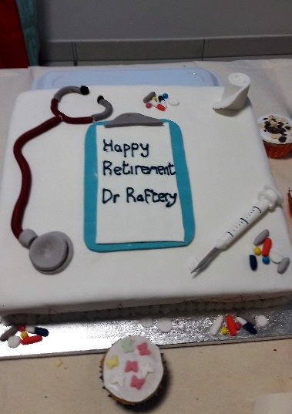 Also to those who had baked a cake especially for the occasion.

I think the turnout on the day goes to prove to us all just how well respected and well regarded Dr Martin Raftery has been over the many years he has devoted to us all.

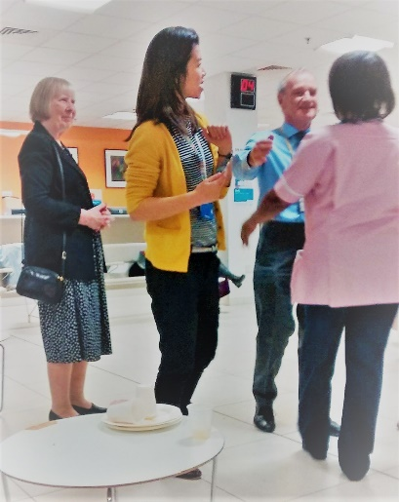My personal experience of meeting Dr Raftery was in 1991 after I received a kidney transplant. I understand this was around the time that Dr Raftery was made clinical director. As you can imagine, in the early stages of being a transplant recipient, I was a regular visitor to the Renal unit on the old Hanbury ward and was regularly met by the good Dr Raftery. 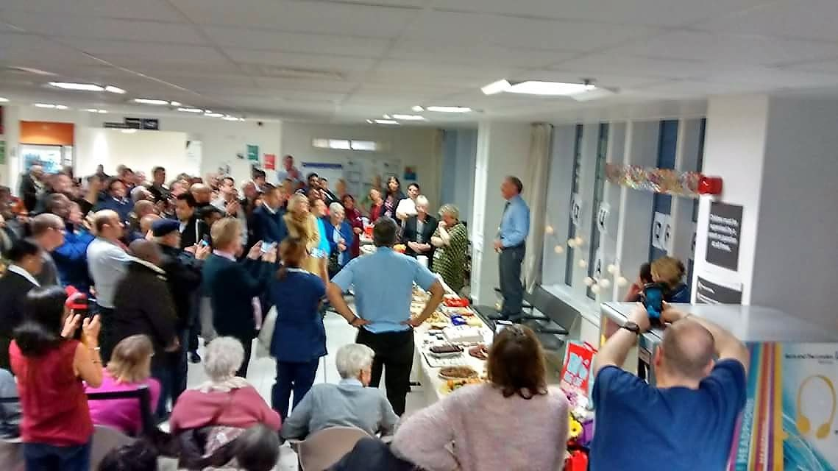

always discuss my condition with me in a very calm and confident manner. I always felt I was in good hands and Dr Raftery would immediately put my parents and myself at ease.

Dr Raftery has many achievements to his name and I know will be sorely missed around the Renal department at the Royal London hospital.

His successor will have big surgical clogs to fill, but we all wish who ever that may be the very best wishes from the RLHKPA.

Dr Raftery has been patron of the RLHKPA for many years and we would look forward to him to remain as our patron for years to come.

I would like end by wishing Dr Martin Raftery a very long, happy and prosperous retirement from us all at The Royal London Hospital.

Carl Postbeschild

Chairman RLHKPA

**World Kidney Day**

March 8th was World Kidney Day and Barts Health Renal Staff, Patients and patients family member manned stalls at locations within the Barts Health Hospitals and also King George Hospital, Redbridge and Queens Hospital, Romford.

The topic this year was Kidneys and Women’s Health.

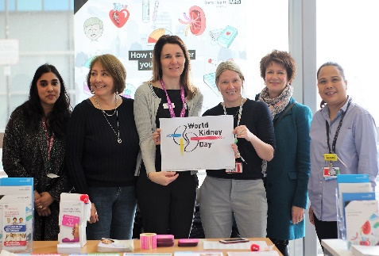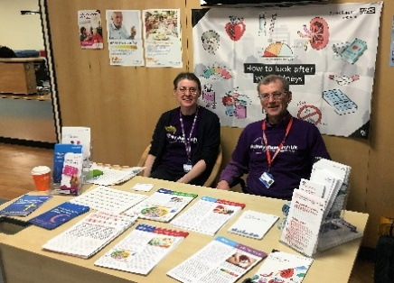Chronic kidney disease (CKD) is a worldwide public health problem. CKD affects approximately **195 million women** worldwideand is currently the 8th leading cause of death in women, with close to **600,000 deaths** each year. Each stall was busy with the set theme of women’s health and kidney disease and the combined effort of giving out Organ Donation pamphlets which is always dear to our hearts.

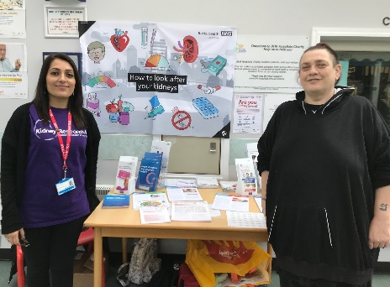Picture 1 shows Damini (nurse) Elaine (mother of and donor for) a patient, Katie, Breeda, Nicki and Andilla (all Renal Staff). Picture 2. Shows the stall at Whipps Cross Hospital admirably staffed by Helen Rainey (Clinical Nurse Specialist) and Brian Gracey (Chair Renal Patients Forum). Picture 3. King George Hospital staffed with Shaila Hussain (Transplant Patient) and Denise Todd (Dialysis Patient). Helen Rainey was also at this locale.

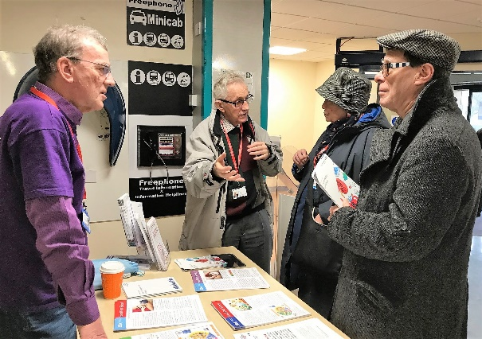Gracey busy talking to visitors to the stall.

Queens’ hospital had a stall in the Atrium and had the added attraction of a live pianist. The pianist was very good and kept the level to piano. Music buffs will know that means soft in Latin. A nice pun there.

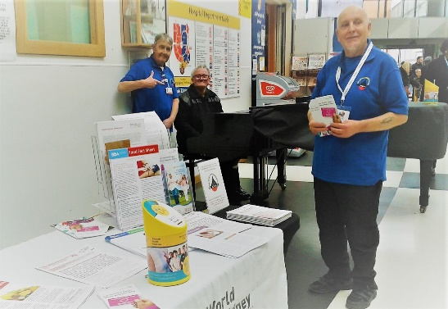

The picture to the right shows Les Petchey and Davis Mansfield, both dialysis Patients with Cliff the pianist in the middle.

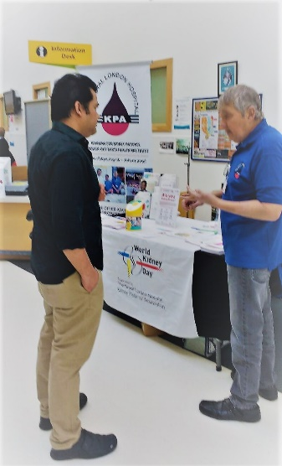On the left we see Les explaining something of earthshattering importance to an apparently enthralled Adrian, Charge Nurse at Queens’ dialysis.

The general consensus is that the day was a worthwhile experience and if anyone has been missed off this listing I can only apologise and say a massive thank you to everyone who gave their time and took part on the day.

**========**

**GIFT AID**

Help us through Gift Aid to help others – and increase every pound you donate.

If you pay UK income tax and you make a gift aid declaration we can claim back this tax (at basic rate) on your donation so your donation is worth 25% more. Please complete the declaration below and send it, with **your donation, to the Treasurer (see back cover).**

Please make **cheques/POs payable to: ‘RLHKPA’**.

THE ROYAL LONDON HOSPITAL KIDNEY PATIENTS’ ASSOCIATION

Registered Charity No. 266660

I/We would like the Association, as a Registered Charity, to treat this donation as a Gift Aid donation on which it may reclaim tax. The person below is a UK Tax Payer.

Surname & Initial………………………………………. Address………………………………………………….

…………………………………………………………..

…………………………………………………………..

**GIVING THROUGH THE SELF ASSESSMENT RETURN (INLAND REVENUE)**

RLHKPA is participating in a scheme that will allow any individual to nominate a charity to receive their tax payments as a donation. Our charity’s name and code number are listed on the IR website.

For the purpose of this scheme the RLHKPA unique code is **QAE95LG.**

**Donations received 1st November, 2017 to 11th**

**March, 2018**

£ 10.00 Monthly donation J & P White

£ 5.00 Monthly donation D Dasandi

£ 15.00 Monthly donation Mr C Turner, Brentwood

£ 20.00 Monthly donation Ahmed Mustaq

£ 60.00 R. Adams & Family Noak Hill-Holiday appreciation

£ 20.00 Mr T. Wright, Thorpe Bay

£ 360.00 In memory of a patient who passed away in August via Renal Unit

£ 25.00 Mrs I Beackom, Bow, in memory of husband Tom

£ 100.00 Mrs Pam Jukes, in memory of husband Geoffrey

£ 10.00 Eileen Torkington, in memory of husband Neil

£ 150.00 Kerry Bailey & Robin Green in appreciation of treatment by Renal Team (Martin Raftery retirement)

£ 974.00 Barclays £4£ matching Justin’s Quiz Night

£ 50.00 Patricia Butler

£ 10.00 Vaseem Ahmed

£ 50.00 In memory of Jane Davies (via Just Giving)

£ 501.00 Mr Vipul Patel, in memory of his father Bhailalbhai

£ 5.00 Ahmed Mustaq

£ 5.00 Ahmed Mustaq

**Collecting Boxes**

## Foreign/Old Coins/scrap metal/stamps

**Fund Raising**

**Grants pending**

£ 9,000.00 Professor Nicola Thomas – Special Project

**Grants paid out**

£ 245.00 One delegate to NKF Conference

£ 5,750.00 Dialysis BCM machine (Queens)

£ 495.00 Refreshments for Memorial Service

£ 252.09 Refreshments for Martin Raftery’s Retirement party

**Poole Flat Lease Extension Costs**

£ 650.00 Dancer Consultancy, flat Valuation Report

£30,393.00 Marcus Baum Solicitors, lease extension

**YOUR KPA COMMITTEE 2017 / 18**

|  |  |
| --- | --- |
| **Patron** | **Martin Raftery** |
| **Clinical Representative** | **Dr Raj Thuraisingham** |
| . |  |
| **Chair** | **Carl Postbechild** [**chair@rlhkpa.org.uk**](mailto:chair@rlhkpa.org.uk) |
| **Vice Chair** | **Brian Gracey** [**briangracey15@gmail.com**](mailto:briangracey15@gmail.com) |
| **Secretary** | **Mark O’Callaghan**  **189 Carlton Road, Romford Essex RM2 5AX**  **07973 309260**  [**RLHKPA@gmail.com**](mailto:RLHKPA@gmail.com) |
| **Treasurer** | **Lesley McGarr**  **6 Foxleigh, Billericay CM12 9NS**  **01277 653759** |
| **Membership Secretary** | **Leslie Petchey**  **42 Ingrebourne Road, Rainham**  **RM13 9AL 07949261586**  [**lespetch@live.co.uk**](mailto:lespetch@live.co.uk) |
| **Holiday Booking** | **Margaret Craddock**  **90 Station Road, West Horndon CM13 3LZ**  **01277 810326** |
| **Marie Niven** | **020 3685 6611** |
| **David Mansfield** | **07547 524105** [**djmansfield1953@gmail.com**](mailto:djmansfield1953@gmail.com) |
| **Adrian Capitan** | **07985 596828** |
| **Pauline Barrett** | **01277 821989** |
| **Glen Maloney** | **07939 218632** [**maloneygw@gmail.com**](mailto:maloneygw@gmail.com) |
| **Tony Fernandes** | **07904323198** [**rockrambler@gmail.com**](mailto:rockrambler@gmail.com) |
| **Co-opted:** | **Ann Spicer**  **Norbert McGarr** |